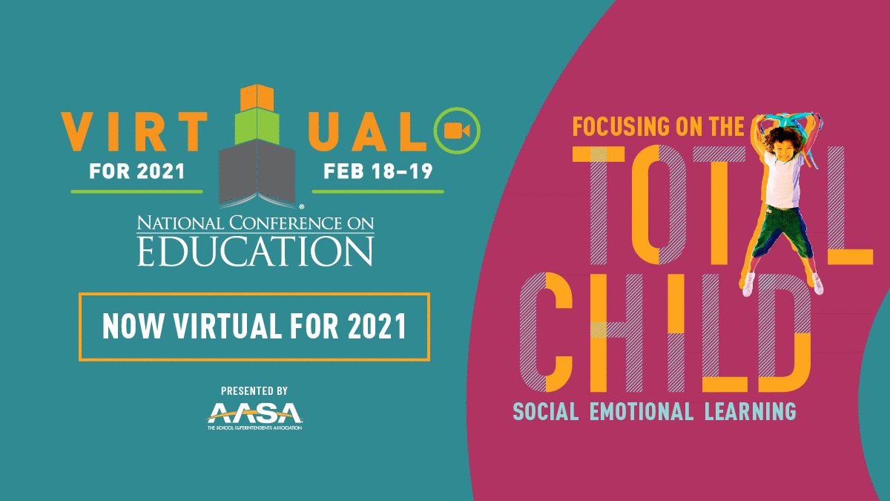
AASA 2021 Virtual National Conference on Education (NCE)
VIP Exhibit Hall Only Invitation
Dear ________________________
On behalf of ____________________________________ (enter your company name), it is our pleasure to share our VIP link to register for a complimentary virtual exhibit hall only pass for AASA’s 2021 Virtual National Conference On Education. (NCE)
- Register, then visit us during the scheduled virtual event days, February 18-19, 2021 and feel free to share this invite with others who may benefit from experiencing all the virtual exhibit hall has to offer.
- If someone from your team registers and misses out during these dates, they can still experience the exhibit hall as the virtual platform will remain live for your learning for 12 full months!
With your VIP Complimentary virtual exhibit hall pass you will be able to:
- View exhibitors and more information while searching via alpha order, booth number and product category.
- Request more information from exhibitors when viewing their booth to learn more about their 2021 offerings.
- Set up private meetings with exhibitors when it works best for you based on your schedule.
- Listen and Learn: Take in recorded presentations within our Virtual School of the Future.
The link to sign up for the virtual exhibit hall is here: https://reg.cmrus.com/aasa2021/
*Select Non-Member Registration, Enter your Details and Select “Exhibit Hall Only” to register.
If you’re interested in attending the education and networking as well, select the full conference registration option!
Enjoy with our compliments and be well!
ENTER YOUR COMPANY INFORMATION HERE:

